Simple is Eco-Friendly but Complex is Effective: Inferences from Visual Complexity in Package Design
Soo Yon Ryu¹, Felipe M. Affonso², and Aner Sela³

¹ Soo Yon Ryu (PhD, University of Florida)
sryu@wlu.edu
The Williams School of Commerce, Economics, and Politics
Washington and Lee University
The Williams School 131, Lexington, VA 24450, USA
Phone: (540) 458-4285

² Felipe M. Affonso (PhD, University of Florida)
felipe.affonso@okstate.edu
School of Marketing & International Business
Oklahoma State University
316 Business Building, Stillwater, OK 74075, USA
Phone: (405) 744-1311

³ Aner Sela (PhD, Stanford University)
aner.sela@warrington.ufl.edu
Warrington College of Business
University of Florida
Stuzin Hall 249D Gainesville, FL 32611, USA
Phone: (352) 273-3271

This work was supported by resources from the University of Florida. All studies in this manuscript were approved by an Institutional Review Board. All authors have access to the source raw data on Qualtrics. The exact stimuli (Qualtrics .qsf file), raw data, and code to reproduce all analyses are publicly available at the Open Science Framework (https://osf.io/h6mk7/?view_only=52d694ee66754a8690ceb221d646052f). All notes, images, and data are currently stored in a project folder on a cloud storage service at the authors’ universities. Supplementary materials are included in the web appendix accompanying the online version of this article.
This article is based on part of the first author’s doctoral dissertation at University of Florida, co-chaired by the third author. Correspondence concerning this article should be addressed to Soo Yon Ryu, The Williams School of Commerce, Economics, and Politics, Washington and Lee University, VA 24450, USA. Email: sryu@wlu.edu.

Abstract

Package design is an important form of point-of-purchase advertising which often conveys information about product characteristics, but can the mere level of its visual complexity produce specific inferences? We suggest that consumers prefer products with visually complex package designs when product efficacy considerations are salient but prefer products with visually simple designs when eco-friendliness considerations are salient. This happens because package design complexity connotes the amount of tangible resources used to produce the product, and consumers associate a low (vs. high) amount of tangible resources with eco-friendliness (vs. efficacy). Our findings extend recent research on design perception and have important practical implications for marketers and product designers. Advertising practitioners can benefit from our findings by understanding when minimalism is valuable, when it is not, and how to strategically use different levels of visual complexity to influence consumer perceptions.

Keywords: aesthetics, visual complexity, minimalism, package advertising, eco-friendliness
Package design is an important form of point-of-purchase advertising, often used to communicate brand claims and attributes to consumers. Beyond explicit textual information, visual elements such as package shape, color, imagery, and graphics often communicate information and influence consumers’ perceptions of product quality, composition, and brand positioning (Hagtvedt and Patrick 2008; Nikulina et al. 2024; Orth and Malkewitz 2008). But could the mere level of visual complexity vs. simplicity of product packaging, independent of the content of any graphics or images, influence consumer inferences? If so, how?
A growing body of research shows that consumers draw inferences from package design’s visual complexity. Visually simple designs suggest healthiness (He, Li, and Chen 2025; Ton, Smith, and Sevilla 2024), masculinity (Chen et al. 2025), authenticity (Wang et al. 2023), and modernity (Favier, Celhay, & Pantin-Sohier 2019), while visually complex designs seem costlier (Min, Liu, and Anderson 2025) and less goal-focused (Chen et al. 2023). We extend this body of work by showing that the inferences consumers draw from package visual complexity, and consequently their preferences, are malleable and dependent on consumers’ salient evaluation criteria and lay theories. As a result, the same degree of visual complexity can drive preferences in opposite directions. We propose and find that consumers prefer products with visually complex package designs when an efficacy criterion is salient, but prefer visually simple package designs when an eco-friendliness criterion is salient. These shifts occur because consumers use visual complexity as a cue for the amount of manufacturing resources used to make the product: visually complex designs signal more resources, implying higher efficacy but lower eco-friendliness, while the opposite is true for visually simple designs.
This research contributes to advertising and consumer behavior scholarship by showing how packaging visual complexity systematically shapes consumer inferences about non-visual product attributes such as manufacturing processes, and by highlighting the roles of salient evaluation criteria and consumer lay theories in these effects. We test our predictions in seven studies (six preregistered) across multiple product categories, including some involving consequential choices. We conclude with implications for advertisers and product designers.

Theoretical background

Defining visual complexity in package design

The advertising literature has long recognized that visual elements serve not just as attention-grabbing devices but as sophisticated rhetorical tools that communicate meaning (McQuarrie and Mick 1999; Scott 1994). This principle is particularly relevant for package design, which functions as a critical form of point-of-purchase advertising. At this final touchpoint before a choice is made, the package must effectively convey brand claims and product attributes, often shaping consumer inferences and choice (Orth and Malkewitz 2008; Zhang et al. 2025).
One important characteristic of any design is its level of visual complexity, a fundamental dimension that characterizes visual stimuli (Berlyne et al. 1968; Donderi 2006). Visual complexity (vs. simplicity) can be defined objectively, based on the quantity and variety of content elements (e.g., lines, shapes, colors) that are physically present in a stimulus (Attneave 1957; Van Geert and Wagemans 2020). It can be operationalized using statistical image properties such as the number of changes in luminance or color across orientations (Braun et al. 2013; Chikhman et al. 2012; Tinio and Leder 2009), computerized measures like file size (Machado et al. 2015), or directly observable characteristics like the number of visual elements. It can also be defined subjectively, based on people’s intuitive judgments of how intricate a stimulus appears to be (Gartus and Leder 2017; Marin and Leder 2013; Nadal et al. 2010). While subjective perceptions of complexity are largely determined by objective complexity, they are also influenced by the conceptual meaning of the stimulus (Chipman and Mendelson 1979) and the relative complexity of a stimulus against its surroundings.
We follow a standard definition of visual complexity from the advertising and branding literature, which holds that stimuli “are visually complex when they contain dense perceptual features (“feature complexity”) and/or when they have an elaborate creative design (“design complexity”)” (Nikulina et al. 2024; Pieters, Wedel, and Batra 2010; p. 48). This definition implies that visual complexity can be multiply determined, encompassing factors such as symmetry, regularity, and the intricacy of individual elements. We operationalize visual complexity by varying the number of distinguishable visual elements within a given area (Pieters et al. 2010; Su et al. 2019). We focus on this dimension because, as we will argue, the lay theory we investigate is logically linked to the amount of visual detail, rather than to creative composition or visual metaphors. Importantly, our operationalization avoids altering elements that carry inherent meaning such as imagery.

How evaluation criteria and lay-theories shape inferences

Consumer evaluation is a constructive process, shaped by the criteria or goals that are salient in the moment (Kruglanski 1996). These criteria trigger – often implicitly – queries that direct attention to relevant product cues, which then inform interpretation and judgment (Johnson et al. 2007). For example, when healthiness is a top-of-mind criterion, a query about nutritional value may come to mind, directing attention to cues like the number of listed ingredients (Raghunathan et al. 2006). If eco-friendliness is the salient criterion, consumers may ask themselves where or how the product was made, prompting them to look for relevant cues on the package. When the criterion is hedonic enjoyment, a query about sensory pleasure may activate, directing attention to visual features like package color (Madzharov et al. 2016; Shankar et al. 2009).
These observed cues are then interpreted through consumers’ beliefs and lay theories to form a judgment (Kruglanski 1996). Under a healthiness criterion, consumers may judge a long ingredient list as unhealthy – if they believe that “fewer ingredients mean healthier”. Under a hedonic criterion, consumers may infer that loud and colorful graphics signal greater enjoyment – if their lay theory equates enjoyment with loud and boisterous energy. In each case, lay theories act as the interpretive lens. If consumers hold a different lay theory (e.g., that healthiness comes from many natural ingredients, or that enjoyment is tied to calmness and serenity), or hold no lay theory at all, the same cue would be interpreted differently (Schwarz 2004; Winkielman and Schwarz 2001; Sela and Berger 2012; Sela, Berger, and Kim 2017). The same visual feature may thus be interpreted differently, depending on the criterion that is salient and the lay theory applied.

Inferences from visual complexity: product efficacy, eco-friendliness, and manufacturing resources

Efficacy and eco-friendliness are among the most top-of-mind evaluation criteria used by modern consumers, particularly in consumer packaged goods (CPG) categories. Here, we define product efficacy in a narrow, utilitarian sense, referring to a product’s functional strength, potency, and capacity to achieve a practical purpose (e.g., the cleaning power of a soap, the absorbent capacity of a paper towel). This definition contrasts with other notions of product “goodness” or “quality,” like healthiness or tastiness, which may be shaped by different lay theories that apply in specific domains like food (Ton et al. 2024). Eco-friendliness refers to the degree to which a product is perceived as not harming the natural environment.
In line with the principle that salient evaluation criteria determine which cues consumers attend to, we argue that when consumers evaluate products’ efficacy or eco-friendliness, they spontaneously seek evidence about the amount of tangible resources involved in its production. By tangible manufacturing resources, we mean the total amount of physical inputs required to make the product itself, including energy, raw materials, production steps, and ingredients (in contrast to intangible resources like knowledge, skills, or time).
Lay theories linking manufacturing resources to a product’s efficacy and eco-friendliness are well-established and intuitive (Tukker et al. 2016), though they operate in opposite directions. While exceptions exist, products that contain more material and require greater tangible resources in production are generally perceived as more efficacious (Gungor and Gupta 1999). For example, a thicker metal casing on a device increases its resistance, a larger amount of active ingredients in a medication increases its therapeutic effect, and more machinery may allow for more sophisticated processes and better quality. In these examples, more production resources intuitively increase a product’s efficacy. At the same time, reducing the amount of tangible manufacturing resources increases perceived eco-friendliness because it decreases waste, resource depletion, environmental pollution, and the product’s carbon footprint (Allwood et al. 2011; Luchs et al. 2010). Companies that incorporate resource-saving production methods are regarded as eco-friendly (Albino et al. 2009), and consumers often consider raw material usage when judging products’ ecological sustainability (Tencel 2023).
A pilot study we conducted (N = 83, web appendix A) supports this intuition. When asked, using an open-ended format, what comes to mind when thinking about how effective or eco-friendly products are (separately, within-subjects), most participants spontaneously mentioned tangible manufacturing resources for both efficacy (67.5%) and eco-friendliness (91.5%).
Whereas the lay theories connecting tangible manufacturing resources with perceptions of efficacy and eco-friendliness are well-established and intuitive, the role of package visual complexity in shaping these perceptions remains less understood. We propose that consumers may also hold a lay theory linking package visual complexity to manufacturing resource use, intuiting that more visually complex designs signal greater use of manufacturing resources, while simpler designs suggest fewer resources.
Although the origins of lay theories are difficult to pinpoint, they often stem from personal experience, self-reflection, or observed co-occurrences between phenomena (Fisher 2003; Kelley and Thibaut 1969; Zane et al. 2020). One potential source of the lay theory linking visual complexity to manufacturing resources is prior experience: brands associated with purity and naturalness often have minimalistic designs (Ton et al. 2024), and consumers may overgeneralize this association (Yang et al. 2023). Even without direct experience, the association may arise from semantic similarity between design features (e.g., the amount of visual detail) and inferred product qualities (e.g., the amount of manufacturing resources; Hutchinson et al. 2003; Masson 1995; McRae and Boisvert 1998). Terms used to describe visually complex designs (e.g., packed, rich, full, dense, abundant) can also describe resource-intensive production. This semantic spillover (Raufeisen et al. 2019) can create an association between package design and beliefs about manufacturing. Importantly, we argue that consumers use package visual complexity as a cue to the product’s underlying manufacturing resources, not merely those of the package itself. Our contribution lies in documenting the existence and consequences of this lay theory, not in empirically testing its origins.

The current research

Drawing these pieces together, we propose that when efficacy or eco-friendliness is a salient evaluation criterion – and in the absence of more diagnostic information (Kardes et al. 2004) – consumers spontaneously seek out cues that signal manufacturing resource use, given the well-established link between manufacturing resources and these judgments. We further suggest that package visual complexity serves as one such cue, because consumers tend to hold a lay theory connecting visual complexity with manufacturing resource abundance. As a result, visually complex packaging is seen as signaling higher efficacy but lower eco-friendliness, whereas simple designs signal the reverse. This, in turn, should increase the preference for complex designs when efficacy is salient and simple designs when eco-friendliness is salient.

Formally:

H1: When efficacy (vs. eco-friendliness) is the salient evaluation criterion, consumers evaluate products with visually complex (vs. simple) package designs more favorably and/or show greater preference for them.
H2: The effect of visual complexity on product evaluation (per H1) is mediated by perceived tangible manufacturing resource usage. Specifically, more visually complex packaging increases perceived resource use, which in turn enhances perceived efficacy and diminishes perceived eco-friendliness.

Consistent with our account of lay theories, we propose that these effects emerge when a lay theory linking visual complexity and manufacturing resources is accessible. Although we expect this lay theory to be common, the effects should attenuate when it is not accessible:

H3: The effect of visual complexity on perceived efficacy and eco-friendliness is moderated by individual differences in the strength of the lay theory connecting design complexity with manufacturing resource usage.

-----------------------------------
Insert figure 1 about here
-----------------------------------

Our conceptualization builds on and extends a growing literature on visual complexity (see Table 1 for a summary). Whereas recent work has largely suggested that “simpler-is-better”, demonstrating that visually simple designs tend to be preferred because they are perceived as purer (Ton et al. 2024), more eco-friendly (Wang et al. 2024), and more authentic (Wang et al. 2023), our work contributes by highlighting the important moderating roles of salient evaluation criteria and lay theories. Rather than treating design complexity as having a universal main effect, we argue that its influence depends on the consumer’s salient evaluation criterion: complexity can be a positive signal of efficacy as well as a negative signal of eco-friendliness, depending on what evaluation criterion is used. This reframes the question from whether design complexity is good or bad to when and why it is helpful. We also show that these effects hinge on consumers’ lay theories and the extent to which they intuit a link between visual complexity and manufacturing resources.

-----------------------------------
Insert table 1 about here
-----------------------------------

We test our propositions in seven experiments (see appendix A for summary of studies), of which six were preregistered, and two replications (web appendices D and F). In Study 1, we test whether consumers’ chronic evaluation criteria influence their preference for products of varying visual complexity, using actual product choices. In Study 2, we extend the findings using a choice task across four different product categories beyond food and manipulating evaluation criterion salience (efficacy vs. eco-friendliness). In Studies 3a and 3b, we test the proposed mechanism, demonstrating that visual complexity (vs. simplicity) increases (vs. decreases) perceptions of tangible production resources and enhances perceived efficacy (vs. eco-friendliness), which influences purchase intentions when there is an alignment between design and salient evaluation criterion. In addition, Study 3 rules out alternative explanations.
In Studies 4a and 4b, we test the moderating role of lay theories regarding the relationship between manufacturing resources and efficacy (Study 4a) and eco-friendliness (Study 4b). Finally, in Study 5, we generalize the main effect to an advertising context, showing that consumers judge complex (vs. simple) ad designs as more appropriate when evaluating efficacy (vs. eco-friendliness). All studies in this manuscript were approved by an Institutional Review Board (IRB202102798) at the University of Florida. In all studies, we followed best practices, including recruiting participants with outstanding participation history and using an attention check prior to random assignment. We report additional attention checks and/or screenings, if any, in the text and additional details for the studies in the web appendix. Additional study materials and data can be found on the Open Science Framework (https://osf.io/h6mk7/?view_only=52d694ee66754a8690ceb221d646052f).

Study 1: Personal evaluation criteria and preference for visual complexity

Study 1 tests H1 using a correlational design with real choice. We predicted that the more participants prioritized an efficacy (vs. eco-friendliness) evaluation criterion when shopping for soap, the more likely they would be to choose a visually complex (vs. simple) product.

Method

Participants and design 260 undergraduate students (59.2% female, M_{age} = 19.92) from a large American university completed the study in exchange for course credit as a part of a 45-minute lab session that included several unrelated studies.

Procedure The first study in the lab session was allegedly a collaboration with a brand developing a new soap product. We showed participants two bar soaps in their respective boxes – a visually complex and a simple one – which we created especially for this session. We operationalized visual complexity and simplicity via the amount of distinguishable visual elements present in the product packages. The visually simple package design consisted of a plain white box with the inscription “Aloe Facial Soap” in green font. The visually complex soap had, in addition, green edges and an abstract pattern of gray circles (appendix B).
We developed the stimuli with three main concerns: (1) realism, (2) minimal use of informative design, and (3) ensuring that the visual complexity was appropriately varied without introducing confounding variables. First, the packages were designed to mimic designs participants would see in stores. Second, we designed these boxes to avoid any informational differences between the two products, such as floral or other figurative patterns that might suggest specific product properties (e.g., green leaves could non-subtly suggest eco-friendliness, and bubbles could suggest cleansing properties, which is related to soap efficacy). Instead, we used the abstract pattern of circles. Further, to make it a conservative test, we used the green color in the ‘complex’ condition, which we hypothesized would be inferred to be more effective, rather than more eco-friendly. Finally, we designed the package in a way that primarily varied in visual complexity, rather than other visual dimensions, such as symmetry. A pretest confirmed the visually complex soap was perceived as more complex than the visually simple soap (web appendix B).
We told participants they would receive their chosen soap at the end of the experimental session, thereby making this a realistic and consequential choice. After indicating their choice, participants provided demographics and continued with the unrelated studies in the session.
At the end of the 45-minute lab session, which included several unrelated studies by other researchers, we measured whether participants saw product efficacy or eco-friendliness as more important to them personally. We told them, “When people make purchases, they usually choose based on what they consider to be important. Please indicate what you consider to be the most important benefits when you are purchasing soaps in general from the options below.” (1 = “having natural ingredients” to 7 = “cleansing the skin,” 1 = “being organic” to 7 = “removing oil and dirt,” and 1 = “eco-friendly ingredients” to 7 = “effective ingredients,” web appendix C). We combined these measures to form an evaluation criterion index where lower scores indicate a greater relative focus on eco-friendliness and higher scores indicate a greater relative focus on efficacy (α = .81). Finally, participants picked up a sample of their chosen soap and left the lab.

Results

Overall, 36.9% of participants chose the soap with the simple design and 63.1% with the complex design. To test our prediction, we conducted a binary logistic regression, regressing soap choice (0 = simple, 1 = complex) on the mean-centered index of personal evaluation criterion. The analysis revealed a significant effect of evaluation criterion (B = .211, Wald χ²(1) = 4.75, p = .029), indicating that as a participant’s focus on efficacy (rather than eco-friendliness) increased, so did their likelihood of choosing the visually complex soap.

Discussion

Using a realistic and consequential correlational design, Study 1 provides preliminary support for our conceptualization. It shows that people are more likely to choose a visually complex (simple) option when an efficacy (eco-friendliness) evaluation criterion is inherently more salient to them. Although correlational designs limit causal inference, they have the advantage of demonstrating the predicted pattern without artificially inducing evaluation criteria. The subsequent studies build on this finding by testing our causal predictions in experimental settings.

Study 2: Experimentally manipulating evaluation criteria

Study 2 was designed to test, using an incentive-compatible experimental design, whether the salience of an efficacy (vs. eco-friendliness) evaluation criterion increases the preference for product options with a visually complex (vs. simple) package design (H1). To bolster the generalizability of the findings, we designed simple and complex versions of products in four categories (soap, energy drink, protein powder, paper towels).

Method

Participants and design Study 2 was preregistered (https://aspredicted.org/5qrt-mn8y.pdf). Based on a recruitment target of 200 and consistent with the preregistration, we collected 196 valid responses from U.S. Prolific participants (52.6% female, M_{age} = 42.00) who passed our preregistered manipulation check and completed the entire study. Participants received a small monetary compensation.
This study had a 2 (evaluation criterion: efficacy vs. eco-friendliness) x 4 (product replicate: energy drink, soap, protein powders, paper towels) mixed design. Evaluation criterion was manipulated between-subjects, and product replicate was a within-subject factor. Each replicate was presented as a choice between a visually complex and a simple option.

Procedure Participants made four consecutive choices, each between two options in a product category (energy drinks, soaps, protein powders, paper towels). Category order was randomized. Before each choice, we asked participants to focus on their assigned evaluation criterion (eco-friendliness or efficacy), which was held constant across the four replicates for each participant. In each choice, we told participants: “On the next page, you will see four paired images of products that are currently being developed. We want you to pick the one that you feel is likely to be the more eco-friendly [vs. effective, depending on the condition] of the two, in terms of how it is made.” To make this an incentive-compatible choice, participants also read: “We will offer ten randomly selected participants to receive the product that they chose once the product is launched.”
For each product category, participants saw a visually complex and a visually simple option side-by-side, presented in a randomized order. In the efficacy criterion condition, we asked participants, “If you needed an/a [energy drink/soap/protein powder/paper towel] to/that [maximize your performance and energy/provides the most powerful cleaning and protection/maximize your muscle growth and performance/absorbs the most and cleans effectively], which one would you purchase?”. In the eco-friendliness criterion condition, we asked, “If you wanted an [energy drink/soap/protein powder/paper towel] that is eco-friendlier and generates less waste, which one would you purchase?”
Visual complexity (simplicity) was operationalized via the number of distinguishable visual elements present on the product package (see appendix C for all stimuli). Package graphic designs consisted of abstract geometrical patterns, to avoid implying any additional information through the design. We pretested all these replicates to ensure participants indeed perceived the visually complex packages as more complex (web appendix B).
After making their four choices, participants provided demographics. Because the presented products were fictitious, we told participants at the end of the study that those selected to receive their chosen option would be contacted through Prolific in the future, once the products were fully developed. We paid participants a special monetary bonus as a substitute for the products.

Results

We ran a generalized estimating equations (GEE) model, which is a generalized form of logistic regression for choices in a repeated-measures design (Liang and Zeger 1986), with a 2 (evaluation criterion) × 4 (product replicate) mixed design. The analysis revealed no evaluation criterion × product replicate interaction (Wald χ²(3) = 4.67, p = .197), suggesting that the pattern of results is consistent across replicates.
A z-test that aggregated all choices of visually complex vs. simple products for each participant showed that in the efficacy maximization condition, the choice share of complex (relative to simple) products was significantly greater than 50% (68.5%, z = 7.40, p < .001). Conversely, in the eco-friendliness evaluation criterion condition, the choice share of simple (relative to complex) products was significantly greater than 50% (75.3%, z = 9.92, p < .001).
The same pattern was observed for each of the replicates individually. In the efficacy maximization evaluation criterion condition, the choice share of visually complex (relative to simple) products was greater than 50% for energy drinks (67%, z = 3.40, p < .001), soaps (65%, z = 3.00, p = .003), protein powders (64%, z = 5.59, p = .005), and paper towels (78%, z = 5.60, p < .001). Conversely, in the eco-friendliness evaluation criterion condition, the choice share of visually simple (relative to complex) products was greater than 50% for energy drinks (75%, z = 4.90, p < .001), soaps (78%, z = 5.51, p < .001), protein powders (73%, z = 4.49, p < .001), and paper towels (75%, z = 4.90, p < .001). As expected, the pattern of results was the same when analyzed using chi-squared tests (all χ²(1)’s > 26.85, p’s < .001).

Discussion

Study 2 provides causal and generalizable evidence for our effect: Participants were more likely to choose a visually complex (vs. simple) option when considering an efficacy (vs. eco-friendliness) evaluation criterion. The effect held across four different product categories, including food and non-food consumer packaged goods. These results extend the generalizability of our findings beyond previous research that focused on food products’ healthiness perceptions (Ton et al. 2024). A conceptual replication of this study is reported in web appendix D.

Studies 3a and 3b: The mediating role of perceived manufacturing resources

Studies 3a and 3b test the effect of design complexity on product inferences and purchase intention using a mediation approach. We have argued that when consumers have an efficacy evaluation criterion, visual complexity (vs. simplicity) increases perceptions of tangible resources used to manufacture the products. In turn, this increases efficacy perceptions, which leads to increased purchase intentions. Our theorizing predicts that the positive effect of visual complexity (vs. simplicity) on purchase intention will be serially mediated by greater perceived resources, followed by perceived efficacy. Given that moderation by evaluation criterion was already established in Study 2, Studies 3a and 3b provide an opportunity to focus more precisely on the mediating process under each criterion separately.
Similarly, when consumers have an eco-friendliness evaluation criterion, visual simplicity (vs. complexity) decreases perceptions of tangible resources used to manufacture the products. In turn, this increases eco-friendliness perceptions, which leads to increased purchase intentions. Our theorizing predicts that the positive effect of visual simplicity (vs. complexity) on purchase intention will be serially mediated by lesser perceived resources, followed by perceived eco-friendliness.
In addition to supporting our theorizing, Studies 3a and 3b test two alternative accounts: aesthetic appeal and conceptual fluency, discussed after the main results. A conceptual replication of this study, reported in web appendix F, rules out additional alternative accounts based on intangible resource use, luxury, prestige, expensiveness, and store brand perceptions. We also rule out a perceptual fluency account.

Study 3a: The effect of complexity under an efficacy criterion

Method

Participants and design Consistent with our preregistration (https://aspredicted.org/zg3q-cx9c.pdf), we recruited 204 U.S. Prolific participants (56.9% female, M_{age} = 38.75) who passed the attention check and completed the entire study. Participants received a small monetary compensation. This study had a 2-cell (visual package design: complex vs. simple) between-subjects design.

Procedure We told participants we were developing a new product and that we were interested in their opinions. Participants read, “Imagine you are shopping for soaps. You go into the store and see the options below. The product we are developing is in the middle on the second shelf.” Participants saw a mock-up stage image of a shelf with nine different soaps, all of which had brand names concealed, purportedly for copyright reasons. In the complex condition, the visually complex target product was presented in the center of the image, surrounded by other products with simpler design. In the simple condition, a relatively simple target product was surrounded by more visually complex products (appendix D).
Next, we measured our dependent variable and mediators in randomized order (see web appendix E). Randomization minimizes systematic influences across measures in either direction and is consistent with prior research (e.g., Sela et al. 2019, Study 1). Purchase intention was measured with a single item, and the activation of an efficacy evaluation criterion was embedded in the question itself: “If you needed a soap that provides the most powerful cleaning and protection, how likely would you be to purchase our soap?” (1 = “extremely unlikely,” to 7 = “extremely likely”).
Our first mediator, perceptions of tangible resource use, was measured using four items: how much energy do you think producing this product requires? (1 = “small amount of energy” to 7 = “large amount of energy”), how many raw materials do you think producing this product requires? (1 = “just a few raw materials” to 7 = “a lot of raw materials”), how many production steps do you think producing this product requires? (1 = “just a few production steps” to 7 = “a lot of production steps”), and how many ingredients do you think producing this product requires? (1 = “just a few ingredients” to 7 = “a lot of ingredients”) (α = .85).
Our second mediator, efficacy perceptions, was measured using four 7-point items adapted from previous research (VanBergen et al. 2020): in general, how effective do you think this soap would be? (1 = “not at all effective” to 7 = “extremely effective”), how much do you think this soap would cleanse your skin? (1 = “not at all” to 7 = “a great deal”), “how effective do you think this soap is in dissolving dirt on your skin? (1 = “not at all” to 7 = “extremely”), and how potent do you think the active ingredients in this soap are? (1 = “not at all potent” to 7 = “extremely potent”) (α = .93; combined to an index of perceived efficacy).
Next, we measured alternative explanations. Aesthetic appeal (“how aesthetic do you think our product is?”; 1 = “not at all aesthetic” to 7 = “extremely aesthetic”), and conceptual fluency (“I had a hard time understanding what the product was about”; 1 = “strongly disagree” to 7 = “strongly agree”). Lastly, we collected demographics and thanked participants.

Results

Purchase intention Supporting our hypothesis, participants indicated they would be more likely to purchase the soap when the package design was visually complex than simple (M_{complex} = 5.29, SD_{complex} = 1.51 vs. M_{simple} = 4.43, SD_{simple} = 1.73; F(1, 202) = 14.45, p < .001; Cohen’s d = .53).

Resource usage perceptions As predicted, participants perceived the product with the visually complex design as requiring more tangible resources than the product with the simple package design (M_{complex} = 5.01, SD_{complex} = 1.05 vs. M_{simple} = 3.92, SD_{simple} = 1.15; F(1, 202) = 50.34, p < .001; Cohen’s d = .99).

Efficacy perceptions As predicted, participants perceived the product with the visually complex design as more efficacious than the product with the simple package design (M_{complex} = 5.33, SD_{complex} = 1.02 vs. M_{simple} = 4.57, SD_{simple} = 1.23; F(1, 202) = 20.58, p < .001; Cohen’s d = .66).

Mediation analysis We conducted a bootstrapping serial mediation analysis using PROCESS Model 6 (Hayes 2023), with design (complex vs. simple) as the independent variable, perceived tangible resources as the first mediator, efficacy perceptions as the second mediator, and purchase intention as the dependent variable. The serial mediation effect was significant (b = .48, 95% CI: [.26 to .75]), supporting our prediction.
One might wonder if the second mediator (i.e., efficacy perception) is redundant, since both this mediator and the purchase intent dependent variable reference the efficacy evaluation criterion and load on a single factor in a confirmatory analysis we conducted. As a robustness check, we conducted a simple mediation analysis including only the manufacturing resources mediator and the purchase intent DV, which was also significant (b = .71, 95% CI: [.40 to 1.06]). Thus, the result does not appear to hinge on any single model specification.

-----------------------------------
Insert figure 2a about here
-----------------------------------

Study 3b: The effect of complexity under an eco-friendliness criterion

Method

Participants and design Consistent with our preregistration (https://aspredicted.org/b5r2-nr34.pdf), we recruited 205 U.S. Prolific participants (53.7% female, M_{age} = 38.17) who passed the attention check and completed the entire study. Participants received a small monetary compensation. This study had a 2-cell (visual package design: complex vs. simple) between-subjects design.

Procedure The procedure was similar to that of Study 3a, again using hypothetical soap products. The manipulation of complexity vs. simplicity was identical to the one described in Study 3a.
Purchase intention was measured with a single item. The activation of an eco-friendliness evaluation criterion was embedded in the question itself: “if you wanted a soap that is eco-friendlier and generates less waste, how likely would you be to purchase our soap?” (1 = “extremely unlikely,” to 7 = “extremely likely).
Our first mediator, perceptions of tangible resource use, was measured using the same four items from Study 3a (α = .89). Our second mediator, eco-friendliness perceptions, was measured using four items, developed to be comparable to the efficacy items used in Study 3a: in general, how eco-friendly do you think this soap would be? (1 = “not at all eco-friendly” to 7 = “extremely eco-friendly”), how biodegradable do you think this soap would be? (1 = “not at all” to 7 = “extremely biodegradable”), how recyclable do you think this soap would be (1 = “not at all” to 7 = “extremely recyclable”), how sustainable do you think the active ingredients in this soap are? (1 = “not at all sustainable” to 7 = “extremely sustainable”) (α = .90; averaged to an index).
Next, we measured aesthetic appeal and fluency using the same items from Study 3a. Lastly, we collected demographics and thanked participants.

Results

Purchase intention Supporting our hypothesis, participants indicated they would be more likely to purchase the soap when the package design was visually simple than complex (M_{complex} = 4.81, SD_{complex} = 1.70 vs. M_{simple} = 5.78, SD_{simple} = 1.18; F(1, 203) = 22.88, p < .001; Cohen’s d = .66).

Resource usage perceptions As predicted, participants perceived the product with the visually simple design as requiring less tangible resources than the product with the complex package design (M_{complex} = 4.86, SD_{complex} = 1.04 vs. M_{simple} = 4.15, SD_{simple} = 1.44; F(1, 203) = 16.39, p < .001; Cohen’s d = .57).

Eco-friendliness perceptions As predicted, participants perceived the product with the visually simple design as more eco-friendly than the product with the complex package design (M_{complex} = 4.58, SD_{complex} = 1.34 vs. M_{simple} = 5.56, SD_{simple} = .99; F(1, 203) = 35.58, p < .001; Cohen’s d = .83).

Mediation analysis We conducted a bootstrapping serial mediation analysis using PROCESS Model 6 (Hayes 2023) with design (simple vs. complex) as the independent variable, tangible resource use as the first mediator, eco-friendliness perceptions as the second mediator, and purchase intention as the dependent variable. The serial mediation effect was marginally significant (b = -.07, 90% CI: [-.16 to -.004]), supporting our prediction. Similar to Study 3a, we also conducted a simple mediation analysis including only the manufacturing resources mediator and purchase intent DV, as a robustness check. This analysis was significant (b = -.10, 95% CI: [-.22 to -.01]), suggesting the pattern is robust and does not hinge on any single model specification.

Alternative Explanations: Studies 3a and 3b

Conceptual and Perceptual Fluency: A conceptual fluency alternative account would predict that a complex design feels more fluent (i.e., cognitively easy to process) under an efficacy criterion, while a simple design feels more fluent under an eco-friendliness criterion. Contrary to this prediction, package design did not influence fluency in either Study 3a (F(1, 202) = .811, p = .369) or Study 3b (F(1, 203) = .075, p = .784).
We also tested a perceptual fluency account in a follow-up study reported in web appendix F. A perceptual fluency account would likewise predict a visual complexity × evaluation criterion interaction, such that complex designs feel more fluent under an efficacy criterion and simple designs feel more fluent under an eco-friendliness criterion. Contrary to this prediction, a follow-up study with roughly 1.5 times the sample of studies 3a and 3b (N = 301), using perceptual fluency measures adapted from prior work (Graf, Mayer, and Landwehr 2018), revealed a nonsignificant interaction effect (F(1, 297) = .28, p = .60), casting doubt on a perceptual fluency explanation. We discuss this alternative account further in Web Appendix F.
It is also not clear why highlighting different evaluation criteria would make simple vs. complex designs more or less fluent to process or perceive in the first place – absent a clear cognitive lay theory underlying such an effect (Schwarz 2004). Moreover, a fluency account struggles to explain why visual complexity influences perceptions of manufacturing resources, both here and in Studies 4a and 4b that follow.

Aesthetic Appeal Note that simple and complex designs are not inherently more or less aesthetically appealing; aesthetically strong or weak designs can occur at either level of complexity. A generalizable aesthetic appeal alternative account would predict that consumers perceive the complex product as more aesthetic under the efficacy evaluation criterion (in Study 3a) – thereby increasing purchase intent – but perceive the simple product as more aesthetic under the eco-friendliness criterion (in Study 3b), likewise boosting purchase intent.
Contrary to this prediction, participants perceived the complex design as more aesthetically appealing than the simple design in both Study 3a (M_{complex} = 5.53, SD_{complex} = 1.47 vs. M_{simple} = 4.18, SD_{simple} = 1.72; F(1, 202) = 36.81, p < .001; Cohen’s d = .85) and Study 3b (M_{complex} = 5.47, SD_{complex} = 1.40 vs. M_{simple} = 4.49, SD_{simple} = 1.78; F(1, 203) = 19.01, p < .001; Cohen’s d = .61). Further, aesthetic appeal was highly correlated with purchase intention both in Study 3a (r = .517, p < .001) and Study 3b (r = .292, p < .001). Because design complexity had opposite effects on purchase intent in Study 3a versus Study 3b, it cannot logically account for the observed pattern. If aesthetic appeal – as distinct from design complexity – were driving the effect, we would expect the pattern to reverse in Study 3b under the eco-friendly criterion – which it did not. We conclude that aesthetic appeal is a spurious perception of the specific stimuli used in this study – the complex version happened to be more aesthetically appealing than the simple one – but this does not account for the reversal of the effect across different evaluation criteria, nor does it generalize to other stimuli where the simple design happens to be more aesthetically pleasing than the complex one.

-----------------------------------
Insert figure 2b about here
-----------------------------------

Discussion: Studies 3a and 3b

Studies 3a and 3b support our hypothesized process by demonstrating that visually complex vs. simple designs can influence perceptions of efficacy and eco-friendliness by increasing vs. decreasing perceptions of tangible production resource usage, respectively. Consequently, visually complex vs. simple designs can increase purchase intentions when consumers have an efficacy vs. eco-friendliness evaluation criterion.
Studies 3a and 3b provide evidence that is inconsistent with conceptual fluency and aesthetic appeal alternative accounts. A conceptual replication of both studies, reported in web appendix F, rules out additional alternative accounts based on perceived intangible resources, luxury, prestige, expensiveness, and budget/store brand. An additional follow-up study casts doubt on a perceptual fluency account.

Studies 4a and 4b: The moderating role of lay theories

Studies 4a and 4b test the effect of design complexity on product inferences using a moderation approach. We have argued that visual complexity (vs. simplicity) influences perceptions of efficacy and eco-friendliness because consumers hold a lay theory according to which visual complexity indicates the amount of tangible manufacturing resources used to make the product. If our theorizing is correct, these effects should be moderated by individual differences in the extent to which consumers hold this lay theory.

Study 4a: lay theories under an efficacy criterion

Method

Participants and design Consistent with our preregistration (https://aspredicted.org/YLT_Q5Y), we recruited 401 U.S. Prolific participants (44.1% female, M_{age} = 39.43) who passed the attention check and completed the entire study. Participants received a small monetary compensation. This study had a 2 (visual design: complex vs. simple) × lay theory (measured, continuous) mixed design.

Procedure We told participants we were developing a new product, a facial soap. The package designs were images of the products used in Study 1 (appendix B). We measured efficacy perceptions using the same four items from Study 3a. This inherently made the efficacy evaluation criterion salient (α = .90).
Then, we measured our moderator, the extent to which people believe that visual design is indicative of the amount of resources used to manufacture the product. We used eight 7-point items adapted from Madan et al. (2022) (e.g., “you can tell how much resources went into making the product from looking at the simple or complex design of the product package”; see web appendix G for all items; 1 = “strongly disagree” to 7 = “strongly agree”; α = .97, combined to a lay theory index). Higher scores reflect a stronger belief that the amount of visual complexity in a package determines the amount of resources used in the product’s manufacturing. Responses on this index were not significantly influenced by the experimental manipulation (F(1, 399) = 2.75, p = .098).

Results

A visual design (simple = 0 vs. complex = 1) × lay theory (continuous, mean-centered) regression analysis revealed a marginal main effect of visual design (ß = .17, t(397) = 1.68, p = .093), suggesting that visual complexity increased perceptions of efficacy. There was no main effect of the lay theory about design and resources (ß = .015, t(397) = .30, p = .762). The main effect of design was qualified by the predicted visual design × lay theory interaction effect (ß = .17, t(397) = 2.45, p = .015; see Figure 3).
As predicted, among participants with stronger beliefs in the link between design resources (1 SD above the mean), visual complexity (vs. simplicity) increased perceived efficacy (ß = .42, t(397) = 2.92, p = .004). Among participants with weaker beliefs in this lay theory (1 SD below the mean), visual complexity (vs. simplicity) did not influence perceived efficacy (ß = -.077, t(397) = -.54, p = .589). The Johnson-Neyman (J-N) point (p < .05) occurred at .12 SD above the mean, demonstrating a mitigation of the proposed effect among those with weaker beliefs in the lay theory.

-----------------------------------
Insert figure 3 about here
-----------------------------------

Study 4b: lay theories under an eco-friendliness criterion

Method

Participants and design Similar to Study 4a, this preregistered study (https://aspredicted.org/LVC_JW5) had a 2 (visual design: complex vs. simple) × lay theory (measured, continuous) mixed design. We recruited 393 U.S. Prolific participants (48.3% female, M_{age} = 41.84), excluding those who did not complete the study or failed the attention check, for a small monetary compensation.

Procedure The procedure was similar to that of Study 4a, except that we used a different product category to extend the generalizability of our effects: an all-purpose lotion. The visually simple package had a relatively plain, white package, whereas the visually complex package had a detailed abstract pattern (appendix E). We measured eco-friendliness perception using four items adapted from Study 3b (see web appendix G), which inherently activated an eco-friendliness evaluation criterion (α = .90; combined to an index).
We measured the same lay theory as in Study 4a, using the same items (α = .97), where higher scores reflect stronger beliefs that package complexity is indicative of the amount of manufacturing resources used. Responses on this index were not influenced by the experimental manipulation (F(1, 391) = .679, p = .411).

Results

A visual design (simple = 0 vs. complex = 1) × lay theory (continuous, mean-centered) regression analysis revealed a main effect of visual design (ß = -.49, t(389) = -4.40, p < .001), suggesting that visual simplicity (i.e., a less complex design) increased perceptions of eco-friendliness. There was a main effect of the lay theory moderator (ß = .366, t(389) = 7.30, p < .001), suggesting that those with stronger beliefs in the design and resources connection perceived the product as more eco-friendly regardless of its visual design. These main effects were qualified by the predicted design × lay theory interaction effect (ß = -.23, t(389) = -3.14, p = .002; see Figure 4).
As predicted, among participants with stronger beliefs in the link between design and resources (1 SD above the mean), visual simplicity (vs. complexity) increased perceived eco-friendliness (ß = -.83, t(389) = -5.34, p < .001). There was no effect among participants with a weaker belief in the lay theory (1 SD below the mean) (ß = -.14, t(389) = -.89, p = .375). The Johnson-Neyman (J-N) point (p < .05) occurred at .65 SD below the mean, demonstrating a mitigation of the proposed effect among those with weaker beliefs in the lay theory.

-----------------------------------
Insert figure 4 about here
-----------------------------------

Discussion: Studies 4a and 4b

Studies 4a and 4b provide convergent evidence in support of our theorizing. We hypothesized that the effects of package design complexity on perceived product efficacy and eco-friendliness, under different evaluation criteria, both reflect people’s lay theory about the relationship between visual complexity and manufacturing resources used. Consistent with our theory, the effect of visual design on efficacy and eco-friendliness perceptions was pronounced among people who generally saw visual complexity in package design as indicative of manufacturing resources – the majority of our sample – but attenuated among those who did not hold such a lay belief.

Study 5: Effect in an advertising context

Study 5 tests our hypothesis using social media advertising context. We told participants we were developing a new product (either high-performing or eco-friendly) and asked them to help us by picking the ad that most appropriately conveyed the high-performance (vs. eco-friendliness) aspect of the product.

Method

Participants and design Consistent with preregistration (https://aspredicted.org/dbwp-cjxd.pdf), we recruited 208 U.S. Prolific participants (52.6% female, M_{age} = 42.00), after excluding those who failed the attention check or did not complete the study, in exchange for a small monetary compensation.
This study had a 2-cell (evaluation criterion: efficacy vs. eco-friendliness) between-subjects design.

Procedure The instructions varied depending on the evaluation criterion condition: participants read that we were developing a new high performance [vs. eco-friendly] energy drink for which they would provide opinions. We asked participants to pick the advertisement that conveyed the high-performance [vs. eco-friendliness] aspect of the product better.
Next, participants saw two advertisements. They resembled social media advertisements displaying the brand name at the top (Liquid Electricity), a call-to-action button (Order Yours), and two energy drink cans positioned around a prominent “Try Now” message. The advertisements had the same elements except for the can’s visual complexity vs. simplicity (appendix F). We used the same energy drink designs from Study 2. Participants chose the ad that they felt better conveyed the focal evaluation criterion, provided demographics, and were thanked.

Results

A chi-square test revealed that participants were more likely to pick the ad featuring the complex design over the simple design in the efficacy evaluation criterion (80.0%) than in the eco-friendliness evaluation criterion (38.8%, χ²(1) = 36.60, p < .001). Subsequent proportion tests showed that in the efficacy evaluation criterion condition, the choice share of the complex ad was significantly greater than 50% (80.0%, z = 6.15, p < .001). Conversely, in the eco-friendliness evaluation criterion condition, the choice share of the simple ad was significantly greater than 50% (61.2%, z = 2.27, p = .023).

Discussion

Study 5 extends our prior findings to a social media advertising context, showing that people intuit that an ad featuring a visually complex design more persuasively conveys efficacy, while an ad featuring a simple design conveys eco-friendliness.

General discussion

What inferences do consumers draw from the mere visual complexity or simplicity of package designs? In this paper, we demonstrate that the answer depends on the focal judgment they seek to make. Extending prior research, which has largely documented a “less-is-better” effect (Table 1), we show that the inferences drawn from visual complexity are moderated by consumers’ salient evaluation criteria. Further diverging from prior research, our findings reveal that these effects are mediated by perceptions of the manufacturing resources involved and moderated by the extent to which people hold a lay theory linking design complexity with resource abundance.
Using a series of realistic and controlled experiments, we show that when an efficacy criterion is salient, consumers prefer products with visually complex designs, but when an eco-friendliness criterion is salient, they prefer visually simple designs. These opposing effects reveal that minimalistic packaging is not universally superior; rather, its value is context-dependent. Our studies demonstrate that these effects are serially mediated by perceptions of tangible manufacturing resources and the subsequent judgments of efficacy or eco-friendliness, casting doubt on alternative explanations such as processing fluency, aesthetic appeal, prestige, and store brand perceptions. Importantly, these findings apply beyond package design and generalize to ad copies that feature these respective package designs.

Theoretical contributions

Our research makes several significant theoretical contributions to the advertising and consumer behavior literatures. First, we identify a key moderator of the effect of visual complexity: consumer’s salient evaluation criterion. Much of the existing literature documents main effects of visual design — for example, showing that simplicity universally signals eco-friendliness (Wang et al. 2024) or authenticity (Wang et al. 2023) — our research is the first to demonstrate that the downstream effects of visual complexity are criterion-contingent and can reverse based on the consumer’s evaluation focus. Authenticity perceptions, for instance, may co-occur with perceptions of resource use, but they are unlikely to drive our effects: they do not account for the observed mediation (Studies 3a and 3b) or moderation (Studies 4a and 4b), both of which hinge on lay beliefs about resource use rather than authenticity. Moreover, there is little conceptual basis to expect authenticity perceptions to increase perceived efficacy, as these constructs are not inherently related. By distinguishing these consumer evaluations, our research offers a more nuanced and complete account of how visual complexity shapes product inferences.
Second, we propose and find evidence for a novel underlying mechanism: perceived tangible manufacturing resources. This mediator is broader than those previously studied in food contexts, such as the number of ingredients (Ton et al. 2024) or the degree of human intervention (He et al. 2025). By conceptualizing resources to include energy, raw materials, and production steps, we provide a more comprehensive explanation for how consumers form judgments, particularly for non-food where ingredient count is less relevant. Our conceptualization of product efficacy in CPG categories extends prior research on package complexity effects in food categories, which has focused on other dimensions of product “goodness,” such as healthiness or tastiness. Different consumption domains are governed by different lay theories and evaluation criteria for what makes a product desirable.
Third, our research contributes to the understanding of how lay theories operate in visual persuasion. We show that the effect of visual complexity on judgment is moderated by the extent to which consumers hold a lay belief connecting design to manufacturing resources. This highlights the crucial role of pre-existing, accessible beliefs in interpreting the meaning of structural design elements in advertising and packaging.
Lastly, the findings might offer a novel explanation for the perceived trade-off between eco-friendliness and efficacy, documented previously in the consumer behavior literature (Luchs et al. 2010). Rather than a mere negative association, our findings suggest that this perceived negative correlation might be partly driven by perceptions of manufacturing resources. Our framework suggests an additional inferential pathway explaining this common association.

Limitations and directions for future research

We demonstrated the effect of graphic package design on inferences, but these effects are likely to be attenuated in the presence of more diagnostic cues, such as explicit product information or strong pre-existing brand associations. Future research could explore the interplay between these subtle design cues and more explicit information. It may also examine the distinction between “feature complexity” (i.e., more dense perceptual features) versus “design complexity” (i.e., more elaborate creative designs; Pieters, Wedel, and Batra 2010) and whether our effect varies as a function of emphasizing these different nuances of visual complexity. Additionally, while we focused on visual density as a key driver of complexity, other dimensions warrant exploration. For instance, asymmetry, color saturation, or the intricacy of individual design elements may trigger similar or different inferences about product attributes. Future research may also further examine the role of aesthetic appeal under different evaluation criteria.
Further, our effects are also most likely to be pronounced for new or unfamiliar brands where the package is a primary source of information. It would be valuable to study how these effects operate for established brands that change their packaging. Relatedly, while our paper documents the existence of the design-resource lay theory, research using different methods could further illuminate the precise psychological origins of this belief.
Importantly, although we included one fully consequential study (Study 1) and another incentive-compatible experiment (Study 2), future research could explore additional tangible consequences of the effect. For example, analyzing actual purchase patterns in an empirical dataset would further strengthen the external validity of our findings.
Additionally, acknowledging that some of our serial mediation effects were modest, future work may gather additional evidence probing the mediating mechanism.

Practical implications for package design

The findings have straightforward practical implications for advertisers, brand managers, and designers.
First, our work offers a practical guide for aligning a product’s core benefit with its package design. When advertising products where efficacy is the primary selling point (e.g., cleaning products, over-the-counter medication), using more visually complex designs may reinforce perceptions of product effectiveness. Conversely, when marketing eco-friendliness, employing visually simple designs across advertising touchpoints may strengthen perceptions of environmental responsibility.
Second, managers must recognize the inherent trade-off. Communicating efficacy via visual complexity may inadvertently harm perceptions of eco-friendliness, and vice versa. Brands must make a strategic choice about which attribute to prioritize in their visual communication. For example, a store brand aiming for a low-cost, eco-friendly perception might benefit from simplicity, even at the risk of being perceived as less effective. A potential strategy to mitigate this trade-off is to use on-pack text to counteract the visual inference (e.g., a simple package that explicitly states “Brewed over 20 hours” to signal resource investment).
Finally, brand maturity matters. While new brands would benefit most from directly applying our findings to clearly communicate their core benefit, established brands could use this framework to reposition or appeal to new segments. For instance, a brand known for efficacy (like Lysol) could adopt a simpler design for a new “green” product line to signal eco-friendliness to consumers who already trust its performance.

APPENDIX A

Study | Sample | Response Variable(s) | Independent Variable(s) / Test Statistics
1 | 268 Undergraduates | Choice of visually complex (vs. simple) soap | Individual differences in efficacy vs. eco-friendliness considerations (measured)
 |  |  | B = .211, χ²(1) = 4.75, p = .029
Findings | Stronger efficacy (vs. eco-friendliness) considerations increases preferences for visually complex (vs. simple) options.
2 | 196 U.S. Prolific Participants | Preference for complex (vs. simple) option across four product replicates | Efficacy evaluation criterion | Eco-friendliness evaluation criterion | Efficacy evaluation criterion |  | Eco-friendliness evaluation criterion
 |  | Overall | 69% vs. 31% | 25% vs. 75% | z = 7.40, p < .001 |  | z = 9.92, p < .001
 |  | Energy drink | 67% vs. 33% | 25% vs. 75% | z = 3.40, p < .001 |  | z = 4.90, p < .001
 |  | Soap | 65% vs. 35% | 22% vs. 78% | z = 3.00, p = .003 |  | z = 5.51, p < .001
 |  | Protein powder | 64% vs. 36% | 27% vs. 73% | z = 5.59, p = .005 |  | z = 4.49, p < .001
 |  | Paper towel | 78% vs. 22% | 25% vs. 75% | z = 5.60, p < .001 |  | z = 4.90, p < .001
Findings | Salient efficacy (vs. eco-friendliness) evaluation criterion increases preference for product with complex (vs. simple) package design.
3a | 204 U.S. Prolific Participants | DVs measured  between-subjects  Replicate: soap | Complex design | Simple design
 |  | DV: Purchase intention  (1–7) | 5.29 (1.51) | 4.43 (1.73) | F(1, 202) = 14.45, p < .001, d = .53
 |  | Mediator: Tangible resource usage perception (1–7) | 5.01 (1.05) | 3.92 (1.15) | F(1, 202) = 50.34, p < .001, d = .99
 |  | Mediator: Efficacy perception (1–7) | 5.33 (1.02) | 4.57 (1.23) | F(1, 202) = 20.58, p < .001, d = .66
Findings | Visually complex (vs. simple) designs can influence perceptions of efficacy by increasing (vs. decreasing) perceptions of tangible production resource usage, influencing purchase intentions when consumers have an efficacy evaluation criterion.
3b | 205 U.S. Prolific Participants | DVs measured  between-subjects  Replicate: soap | Complex design | Simple design
 |  | DV: Purchase intention  (1–7) | 4.81 (1.70) | 5.78 (1.18) | F(1, 203) = 22.88, p < .001, d = .66
 |  | Mediator: Tangible resource usage perception (1–7) | 4.86 (1.04) | 4.15 (1.44) | F(1, 203) = 16.39, p < .001, d = .57
 |  | Mediator: Eco-friendliness perception (1–7) | 4.58 (1.34) | 5.56 (.99) | F(1, 203) = 35.58, p < .001, d = .83
Findings | Visually simple (vs. complex) designs can influence perceptions of eco-friendliness by decreasing (vs. increasing) perceptions of tangible production resource usage, influencing purchase intentions when consumers have an eco-friendliness evaluation criterion.
4a | 401 U.S. Prolific Participants | Replicate: soap | Strong beliefs in lay theory  (1 SD above mean) |  | Weak beliefs in lay theory  (1 SD below mean)
 |  | DV: Efficacy perception (1–7) | Complex design | Simple design | Complex design |  | Simple design
 |  |  | 5.28 | 4.86 | 4.74 |  | 4.82
 |  |  | ß = .419, t(397) = 2.92, p = .004 |  | ß = -.077, t(397) = -.54, p = .589
Findings | Effects more pronounced among consumers who associate design complexity (simplicity) with more (less) tangible resources
4b | 393 U.S. Prolific Participants | Replicate: all-purpose lotion | Strong beliefs in lay theory  (1 SD above mean) |  | Weak beliefs in lay theory  (1 SD below mean)
 |  | DV: Eco-friendliness perception (1–7) | Complex design | Simple design | Complex design |  | Simple design
 |  |  | 4.39 | 5.20 | 3.97 |  | 4.13
 |  |  | ß = -.83, t(389) = -5.34, p < .001 |  | ß = -.139, t(389) = -.89, p = .375
Findings | Effects more pronounced among consumers who associate design complexity (simplicity) with more (less) tangible resources
5 | 208 U.S. Prolific Participants | Choice of visually complex (vs. simple) product advertisement | Choice share of complex ad  in efficacy evaluation criterion |  |  | Choice share of simple ad  in eco-friendliness evaluation criterion
 |  |  | Greater than 50%  80%, z = 6.15, p < .001 |  |  | Greater than 50%  61.2%, z = 2.27, p = .023
Findings | Consumers believe a visually complex (vs. simple) option is more appropriate to advertise an option to convey efficacy (vs. eco-friendliness).

APPENDIX B

Visually Complex Stimuli | Visually Simple Stimuli
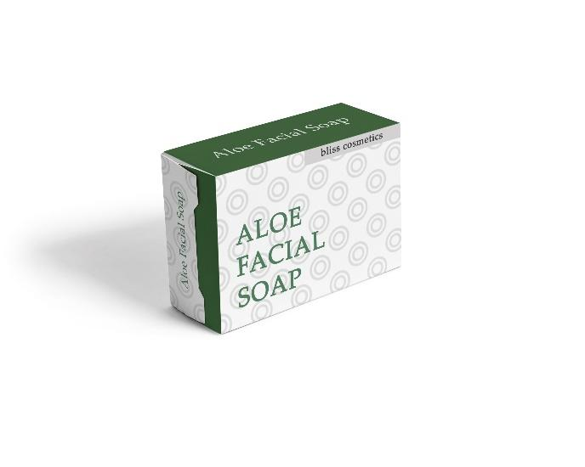 | 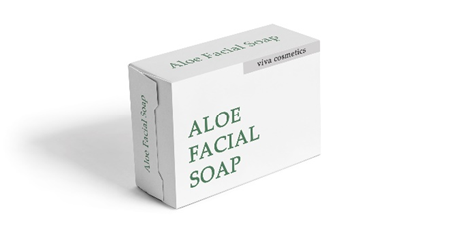

APPENDIX C
In each product category, participants were shown one of two randomly assigned pairs, each consisting of a complex and simple product with different brand names.
Visually Complex Stimuli | Visually Simple Stimuli
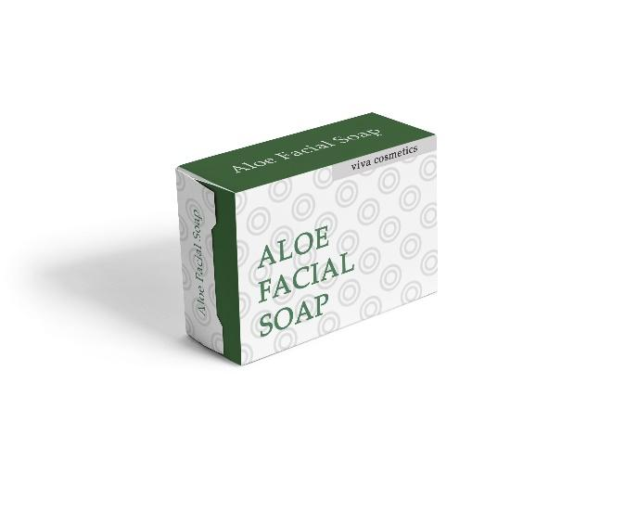 | 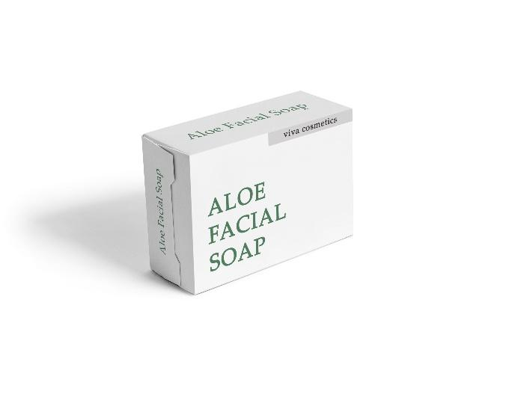  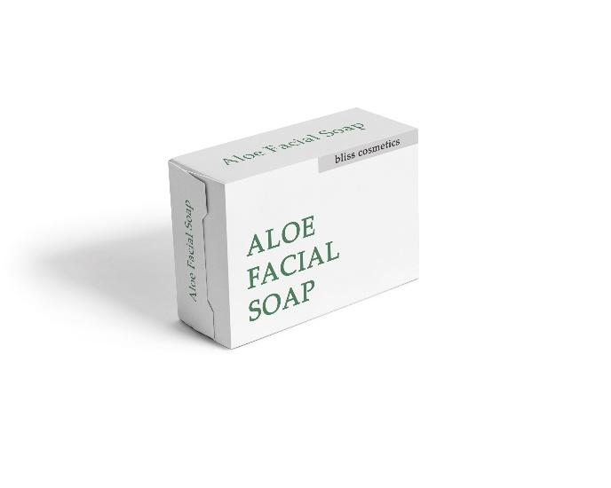
   |   
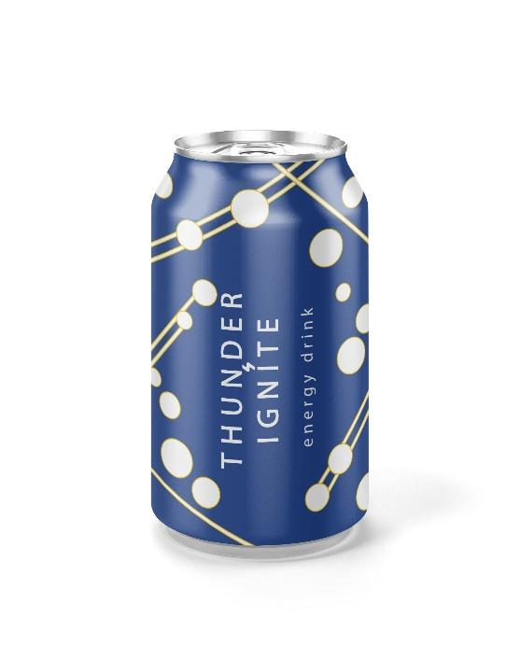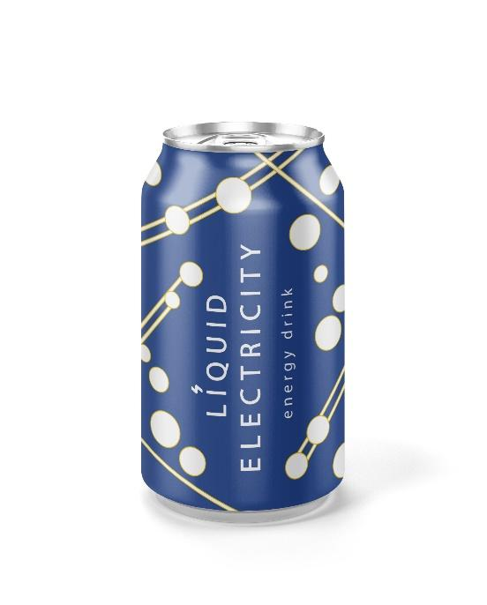 | 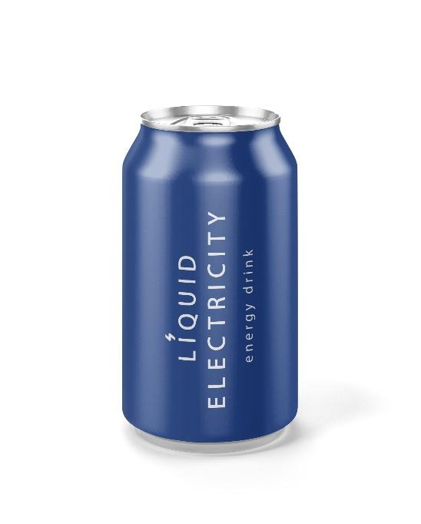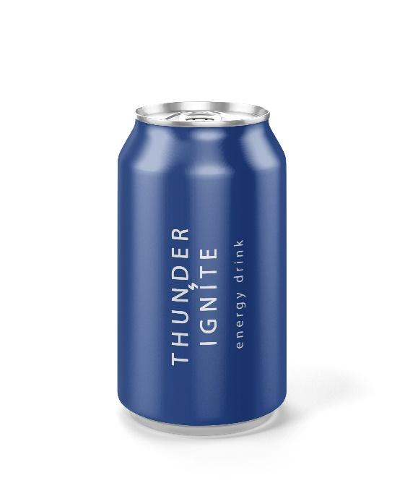
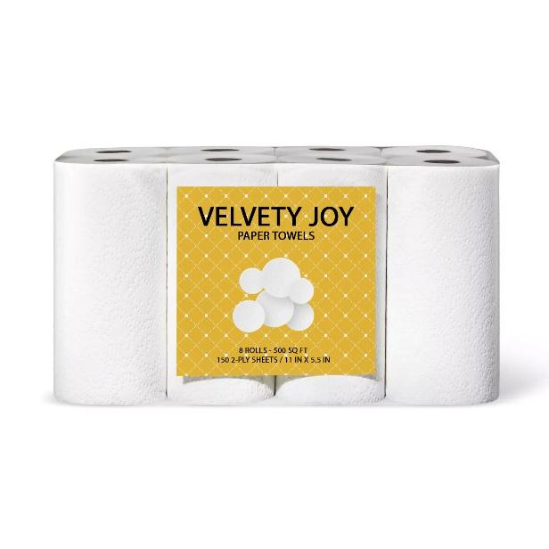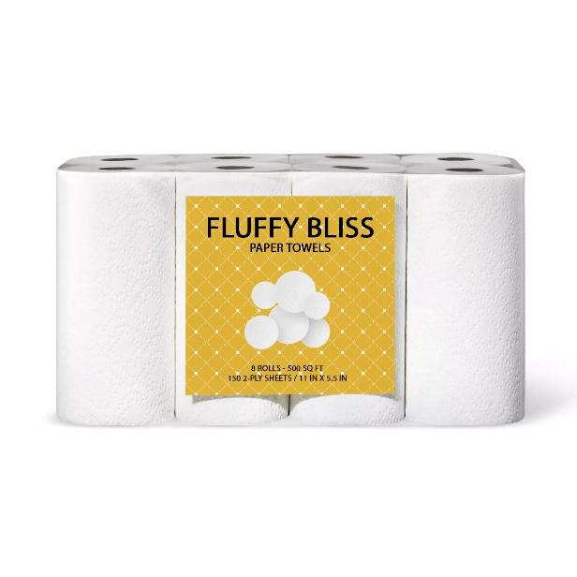 | 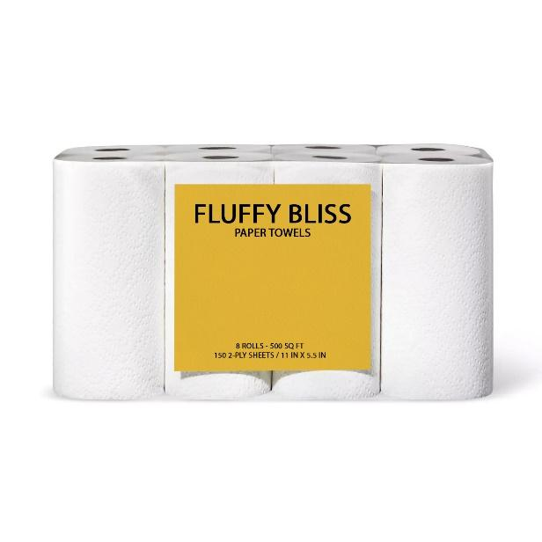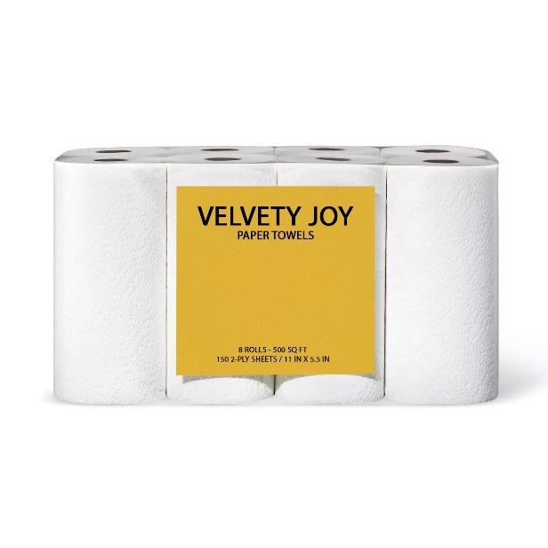

APPENDIX D

Study 3a & 3b Stimuli
Visually Complex Target Product | Visually Simple Target product
 | 

APPENDIX E

Study 4b Stimuli
Visually Complex Stimuli | Visually Simple Stimuli
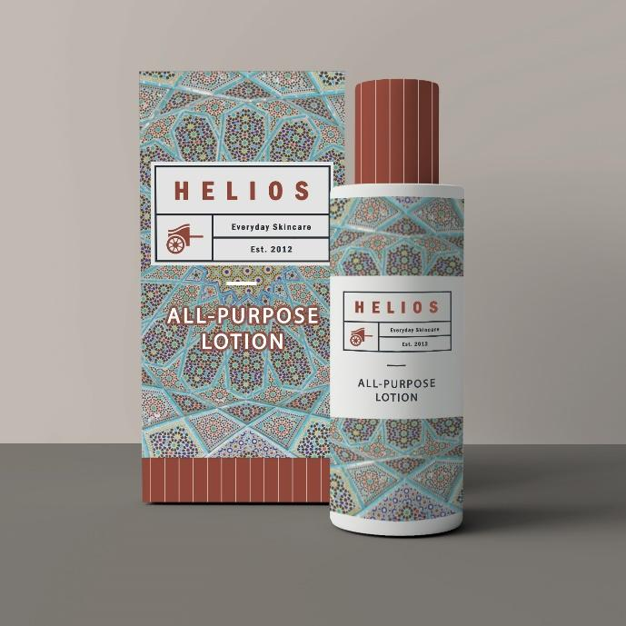 | 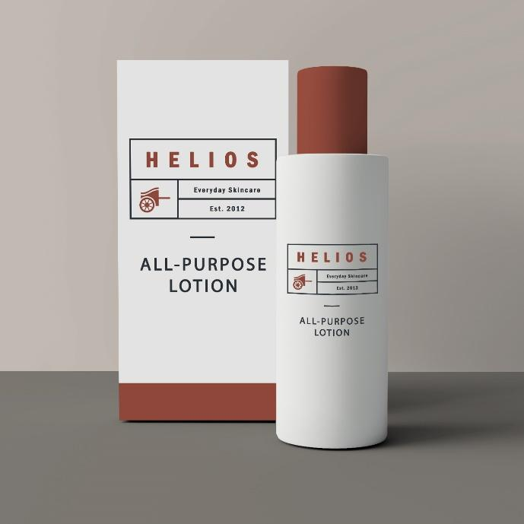

APPENDIX F

Visually Complex Stimuli | Visually Simple Stimuli
 | 

REFERENCES

Albino, V., Balice, A., & Dangelico, R. M. (2009). Environmental strategies and green product development: An overview on sustainability-driven companies. Business Strategy and the Environment, 18(2), 83–96.
Allwood, J. M., Ashby, M. F., Gutowski, T. G., & Worrell, E. (2011). Material efficiency: A white paper. Resources, Conservation and Recycling, 55(3), 362–381.
Attneave, F. (1957). Physical determinants of the judged complexity of shapes. Journal of Experimental Psychology, 53(4), 221–227.
Berlyne, D. E., Ogilvie, J. C., & Parham, L. C. (1968). The dimensionality of visual complexity, interestingness, and pleasingness. Canadian Journal of Psychology, 22(5), 376–387.
Braun, J., Amirshahi, S. A., Denzler, J., & Redies, C. (2013). Statistical image properties of print advertisements, visual artworks, and images of architecture. Frontiers in Psychology, 4(Nov), 1–15.
Chen, S., Ponomarenko, V., Lv, L., & Ahlstrom, D. (2025). Visual complexity, brand gender, and ad effectiveness. International Journal of Research in Marketing, 42(2), 365–390.
Chen, S., Xiao, T., Xiong, J., & Peng, K. (2023). Occam's razor effect in packaging: The impact of simple versus complex aesthetics on product efficacy judgments. Acta Psychologica Sinica, 55(11), 1872–1888.
Chikhman, V., Bondarko, V., Danilova, M., Goluzina, A., & Shelepin, Y. (2012). Complexity of images: Experimental and computational estimates compared. Perception, 41(6), 631–647.
Chipman, S. F., & Mendelson, M. J. (1979). Influence of six types of visual structure on complexity judgments in children and adults. Journal of Experimental Psychology: Human Perception and Performance, 5(2), 365–378.
Ding, Y., Meng, X., & Sun, C. (2024). Simplicity matters: Unraveling the impact of minimalist packaging on green trust in daily consumer goods. Sustainability, 16(12), 4932.
Donderi, D. C. (2006). Visual complexity: A review. Psychological Bulletin, 132 (1), 73–97.
Favier, M., Celhay, F., & Pantin-Sohier, G. (2019). Is less more or a bore? Package design simplicity and brand perception: An application to Champagne. Journal of Retailing and Consumer Services, 46, 11–20.
Fisher, C. D. (2003). Why do lay people believe that satisfaction and performance are correlated? Possible sources of a commonsense theory. Journal of Organizational Behavior, 24(6), 753–777.
Gartus, A., & Leder, H. (2017). Predicting perceived visual complexity of abstract patterns using computational measures: The influence of mirror symmetry on complexity perception. PLoS ONE, 12(11), 1–29.
Graf, L. K., Mayer, S., & Landwehr, J. R. (2018). Measuring processing fluency: One versus five items. Journal of Consumer Psychology, 28(3), 393-411.
Gungor, A., & Gupta, S. M. (1999). Issues in environmentally conscious manufacturing and product recovery: A survey. Computers and Industrial Engineering, 36(4), 811–853.
Hagtvedt, H., & Patrick, V. M. (2008). Art infusion: The influence of visual art on the perception and evaluation of consumer products. Journal of Marketing Research, 45(3), 379–389.
Hayes, A. F. (2023). Introduction to Mediation, Moderation, and Conditional Process Analysis: A Regression-Based Approach (3rd ed.). New York, NY: The Guilford Press.
He, Y., Li, X., & Chen, Z. (2025). Aversion to human intervention: Why food in complex packaging design is perceived as less healthy. Psychology & Marketing, 42(3), 907–920.
Hutchinson, A., Whitman, R. D., Abeare, C., & Raiter, J. (2003). The unification of mind: Integration of hemispheric semantic processing. Brain and Language, 87(3), 361–368.
Johnson, E. J., Häubl, G., & Keinan, A. (2007). Aspects of endowment: A query theory of value construction. Journal of Experimental Psychology: Learning Memory and Cognition, 33(3), 461–474.
Kardes, F. R., Posavac, S. S., & Cronley, M. L. (2004). Consumer inference: A review of processes, bases, and judgment contexts. Journal of Consumer Psychology, 14(3), 230–256.
Kelley, H. H., & Thibaut, J. W. (1969). Group problem solving. In G. Lindzey & E. Aronson (Eds.), The Handbook of Social Psychology (2nd ed., pp. 1–101). Oxford, UK: Addison-Wesley.
Kruglanski, A. W. (1996). Goals as knowledge structures. In P. M. Gollwitzer & J. A. Bargh (Eds.), The Psychology of Action: Linking Cognition and Motivation to Behavior (pp. 599–618). New York, NY: The Guilford Press.
Liang, K. Y., & Zeger, S. L. (1986). Longitudinal data analysis using generalized linear models. Biometrika, 73(1), 13–22.
Light, N., & Fernbach, P. M. (2024). Keep it simple? Consumer perceptions of brand simplicity and risk. Journal of Marketing Research, 61(6), 1152–1170.
Luchs, M. G., Naylor, R. W., Irwin, J. R., & Raghunathan, R. (2010). The sustainability liability: Potential negative effects of ethicality on product preference. Journal of Marketing, 74(5), 18–31.
Machado, P., Romero, J., Nadal, M., Santos, A., Correia, J., & Carballal, A. (2015). Computerized measures of visual complexity. Acta Psychologica, 160, 43–57.
Madan, S., Savani, K., & Johar, G. V. (2022). How you look is who you are: The appearance reveals character lay theory increases support for facial profiling. Journal of Personality and Social Psychology, 123(6), 1223–1242.
Madzharov, A. V., Ramanathan, S., & Block, L. G. (2016). The halo effect of product color lightness on hedonic food consumption. Journal of the Association for Consumer Research, 1(4), 579–591.
Marin, M. M., & Leder, H. (2013). Examining complexity across domains: Relating subjective and objective measures of affective environmental scenes, paintings and music. PLoS ONE, 8(8), 1–35.
Masson, M. E. J. (1995). A distributed memory model of semantic priming. Journal of Experimental Psychology: Learning, Memory, and Cognition, 21(1), 3–23.
McRae, K., & Boisvert, S. (1998). Automatic semantic similarity priming. Journal of Experimental Psychology: Learning Memory and Cognition, 24(3), 558–572.
McQuarrie, E. F., & Mick, D. G. (1999). Visual rhetoric in advertising: Text-interpretive, experimental, and reader-response analyses. Journal of Consumer Research, 26(1), 37–54.
Min, L., Liu, P. J., & Anderson, C. (2025). The visual complexity = higher production cost lay belief. Journal of Consumer Research, 61(2), 1167–1185.
Nadal, M., Munar, E., Marty, G., & Cela-Conde, C. (2010). Visual complexity and beauty appreciation: Explaining the divergence of results. Empirical Studies of the Arts, 28(2), 173–191.
Nikulina, O., van Riel, A. C. R., Lemmink, J. G. A. M., Grewal, D., & Wetzels, M. (2024). Narrate, act, and resonate to tell a visual story: A systematic review of how images transport viewers. Journal of Advertising, 53(4), 605–625.
Orth, U. R., & Malkewitz, K. (2008). Holistic package design and consumer brand impressions. Journal of Marketing, 72(3), 64–81.
Pieters, R., Wedel, M., & Batra, R. (2010). The stopping power of advertising: Measures and effects of visual complexity. Journal of Marketing, 74(5), 48–60.
Pracejus, J. W., Olsen, G. D., & O’Guinn, T. C. (2006). How nothing became something: White space, rhetoric, history, and meaning. Journal of Consumer Research, 33(1), 82–90.
Putrevu, S., Tan, J., & Lord, K. R. (2004). Consumer responses to complex advertisements: The moderating role of need for cognition, knowledge, and gender. Journal of Current Issues & Research in Advertising, 26(1), 9–24.
Raghunathan, R., Naylor, R. W., & Hoyer, W. D. (2006). The unhealthy = tasty intuition and its effects on taste inferences, enjoyment, and choice of food products. Journal of Marketing, 70(4), 170–184.
Raufeisen, X., Wulf, L., Köcher, S., Faupel, U., & Holzmüller, H. H. (2019). Spillover effects in marketing: Integrating core research domains. AMS Review, 9, 249–267.
Schwarz, N. (2004). Metacognitive experiences in consumer judgment and decision making. Journal of Consumer Psychology, 14(4), 332–348.
Scott, L. M. (1994). Images in advertising: The need for a theory of visual rhetoric. Journal of Consumer Research, 21(2), 252–273.
Sela, A., & Berger, J. (2012). How attribute quantity influences option choice. Journal of Marketing Research, 49(6), 942–952.
Sela, A., Berger, J., & Kim, J. (2017). How self-control shapes the meaning of choice. Journal of Consumer Research, 44(4), 724–737.
Sela, A., Hadar, L., Morgan, S., & Maimaran, M. (2019). Variety‐seeking and perceived expertise. Journal of Consumer Psychology, 29(4), 671-679.
Shankar, M. U., Levitan, C. A., Prescott, J., & Spence, C. (2009). The influence of color and label information on flavor perception. Chemosensory Perception, 2(2), 53–58.
Su, L., Wan, E. W., & Jiang, Y. (2019). Filling an empty self: The impact of social exclusion on consumer preference for visual density. Journal of Consumer Research, 46, 808–824.
Tencel. (2023). Lenzing survey shows that ‘transparency’ is key for clothing and home textiles brands to win consumer trust and confidence, with ‘eco-friendly’ and ‘biodegradable’ being favorable terms that increase likelihood of purchase. https://www.tencel.com/news-and-events/lenzing-survey-shows-that-transparency-is-key-for-clothing-and-home-textiles-brands-to-win-consumer-trust-and-confidence-with-eco-friendly-and-biodegradable-being-favorable-terms-that-increase-likelihood-of-purchase.
Tinio, P. P. L., & Leder, H. (2009). Just how stable are stable aesthetic features? Symmetry, complexity, and the jaws of massive familiarization. Acta Psychologica, 130(3), 241–250.
Ton, L. A. N., Smith, R. K., & Sevilla, J. (2024). Symbolically simple: How simple packaging design influences willingness to pay for consumable products. Journal of Marketing, 88(2), 1–68.
Tukker, A., Bulavskaya, T., Giljum, S., de Koning, A., Lutter, S., Simas, M., Stadler, K., & Wood, R. (2016). Environmental and resource footprints in a global context: Europe’s structural deficit in resource endowments. Global Environmental Change, 40, 171–181.
VanBergen, N., Irmak, C., & Sevilla, J. (2020). Product entitativity: How the presence of product replicates increases perceived and actual product efficacy. Journal of Consumer Research, 47(August), 192–214.
Van Geert, E., & Wagemans, J. (2020). Order, complexity, and aesthetic appreciation. Psychology of Aesthetics, Creativity, and the Arts, 14(2), 135–154.
Yang, Y., Li, X., & Hsee, C. K. (2023). Relevance insensitivity: A framework of psychological biases in consumer behavior and beyond. Consumer Psychology Review, 6(1), 121–132.
Zane, D. M., Smith, R. W., & Reczek, R. W. (2020). The meaning of distraction: How metacognitive inferences from distraction during multitasking affect brand evaluations. Journal of Consumer Research, 46(5), 974–994.
Zhang, Y., Kwak, H., Puzakova, M., & Taylor, C. R. (2025). Turning right: The impact of text rotation (left vs. right) on consumer product preferences. Journal of Advertising, 1–19.
Wang, X., Chen, J., Ma, C., & Jiang, Y. (2024). Simpler is greener: The impact of packaging visual complexity on products' eco-friendliness perception. Psychology & Marketing, 41(12), 2992–3008.
Wang, Y., Jiang, J., Gong, X., & Wang, J. (2023). Simple = authentic: The effect of visually simple package design on perceived brand authenticity and brand choice. Journal of Business Research, 166, 114078.
Winkielman, P. & Schwarz, N. (2001). How pleasant was your childhood? Beliefs about memory shape inferences from experienced difficulty of recall. Psychological Science, 12(2), 176–179.

